Player Performance Evaluation

NOTE: It is important to understand this review is based on your performance during the evaluation period. It does not reflect your ability to succeed in the game of basketball. It is simply a tool for improvement and a method for coaches to assign teams.

Last Name: Givens First Name: Bryant Level: DII

College: CSU Age: 22 Height: 6’0 Weight: 190

Position: PG Reviewer: DF Date: 01-03/19

Playing experience:
Columbus State University: Currently, starting point guard finishing junior playing year.

Northeast Mississippi Community College: Played in 26 games...Averaged 9.38 points per game.
Lincoln Trail College: Played one season...Played in 28 games...Averaged 12.1 points, 3.8 rebounds, and 3.6 assists per game.
High School: Graduated from South Bend Washington High School.

Shooting Strength Dribbling Strength Passing Strength
3 Mechanics & Arc ** 3 Goes both ways _4 Vision **
5 Range 2 point 5 Sees the floor ** __5 Court sense
5 Range 3 point 4 Handles pressure __4 Turnovers
4 Catch & Shoot 5 Speed __4 Play maker
4 Shoot off dribble 5 Dribbles with purpose __5 Catches well **
3 Back to Basket 4 Under control ** __5 2 handed
3 Use of weak hand 5 Penetrates to hoop __4 1 handed
3 Rebounding ** 4 Ability to finish __4 Overhead

Individual Strength Defensive Strength Overall Strength
5 Attitude ** 5 On the ball __5 Scorer
5 Accept criticism ** 4 Off the ball __4 Rebounder
5 Cooperation ** 4 Transition ** __5 Defender
5 Work ethic ** 4 Help __4 Play maker
5 Team play ** 5 Recover to man __5 Understands game
5 Hops 5 Close out __4 Sets screens
5 Speed _4 Anticipation ** __5 Cuts/Uses screens
5 Quickness 4 Team concepts ** __5 Asset to team **

Player Position Overall Evaluation
X 1 X 5 = Solid
2 4 = Average
3 3 = OK
4 2 = Needs improvement
5 1 = Needs more development at a lower level

Comments:

Defense
Any guard that can master the ability to have more steals or caused turnovers than fouls in a game, we are looking at a high level of play. Bryant goes above and beyond what simplistic basketball fundamentals teach us. Can you go 37 minutes playing with energy, aggression, applying ball pressure, causing turnovers, diving for loose balls and grabbing rebounds and say you had no fouls at all. This is elite level playing from the junior Guard from South Bend, Indiana. Quickness on top of speed is a deadly mixture and Givens possesses both. Every possession doesn't end with a steal, and you may score on him about 9% of the time, but even those few successful attempts come with a cost of a lot of energy and a long shot clock. You can't get around him one on one.

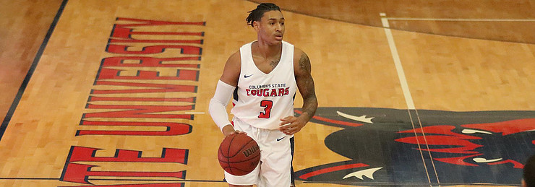

Offense
Court vision is the first thing that catches my eye about the guard, he sees everything and will let you know that he failed to make a pass but still seen you. Every shot that Givens puts up is seemingly set up in his own mind from the beginning of the play, he set up his teammates with effortless passing and is able to knock down shots without a flinch. If the ball is on the floor, he is going to get around you and then has a triple threat of weapons up his sleeve once he does. We know the shot, we know the pass, but what is the 3rd in the triple threat once the dribble is already taken? It's replaced with a skill called getting to the line, which a lot of point guards fail to do because they are afraid of the contact or the flop and fail to take real shot attempts. Going to the foul line is a skill set in its self and it comes with the ability to make your defender respect the other aspects of your game. He does what he wants.

Leadership
I watched in the 72 seconds Givens sat on the bench as the Columbus State Cougars played host to a hungry Georgia Southern team. His energy from the floor traveled with him to the bench as he clapped up his team, yelled to the floor, repeated plays after Coach Moore called them and rarely stayed seated. His team felt his energy from the bench and it in a sense kept his presence on the floor. At practice I hear the junior guard talking the entire practice, telling his teammates to keep going, to run harder, clapping them up after good moves and to uplift them after bad ones. A player with the ability to lead is not the same thing as your highest scorer, or most popular player but Givens has a star quality about him that draws attention to his game. The team respects him, the coaches love him, and the scouts are glued to him. He will make you better.

Next Level
Givens has another year left of school, so I'd love to see him in 2020 headed to all levels of tryouts. He can easily be successful overseas, but I would like him to take his talent to a G-League tryout and work a 2 way deal out with one of those teams. Reading this you'll picture it being seemingly easy, and it's not but this young man deserves a spot with a NBA franchise. He is next level built.

Junior Year Stats
Continued on next page.

Field Goal Percentage is .396
Three Point Percentage is .315
Total of 226 Points

Steals 28
Assists 107
Rebounds 70 (12 off and 58 Def)

